Process Performance Model Creation
Guideline

Revision History

Version | Updated By | Date | Approved By | Change Request ID | Significant Changes
1.0 | SEPG | 04-Jan-18 | Manoj Nagpal | NA | Initial Version
1.1 | Prabhakar | 30-Mar-22 | Manish Singla | NA | Added the threshold for probability of success under section A of this document. Highlighted in grey.

- Process Performance Model (PPM)
- PPMs are used to estimate or predict the value of a process performance measure from the values of other people, process, product, and service measurements.
- PPMs typically use people, process and product measurements collected throughout the life of the project to estimate progress toward achieving objectives that cannot be measured until later in the project’s life
- The PPM model is derived from business objectives for the measures aligned to Quality & Process Performance Objectives (QPPO) covering the process, product and people measures of process & sub processes.
- The objective is to proactively manage Projects and achieve their business objectives.
- Threshold for Probability of success is defined 75%

- Healthy Ingredients of Process Performance Models.

- Statistical, probabilistic or simulation in nature.
- Predict interim and/or final project outcomes that cannot be measured until later in the project’s life cycle.
- Use controllable factors tied to sub-processes to conduct the prediction Model the variation of factors and understand the predicted range or variation of the outcomes.
- Enable “what-if “analysis for project planning, dynamic re-planning and problem resolution during project execution.
- Connect “upstream “activity with “downstream “activity Enable projects to achieve mid-course corrections to ensure project success.
- Developed from historical process performance data or Current Process Baseline.
- Projects can use PPM at all applicable phases before moving into User Acceptance phase.

- Tool & Techniques of Building PPMs

- Minitab Tool
- Hypothesis
- Regression
- Box Plot
- Normality Test
- Control Chart
- Capability Chart

- PPM building

  - Process performance model concepts

- The concept behind building PPM is the multi linear equation stating that your outcome is a result or function of many inputs (x1, x2, x3.... etc).

Y (Response or Outcome) = f(x), x1, x2, ….. xn
Dependent | Independent
Effect | Cause
E.g. SLA Compliance | E.g.: Avg. Domain Exp., Req. Stability, Design complexity

- PPM will be built at organizational level or at service line level depending on the availability of data as determined by the SEPG council which is based on their respective service lines, impacted processes & sub-processes.
- The process performance baselines (PPB) as well as the process performance models need to be exclusively prepared and calibrated. PPM Models are derived from Process Performance Baseline.
- Note: - To develop PPM Model at service line level, pre-requisite is that the PPBs should be available for the same service line.

  - Identify high level business objectives

- The steering committee (senior management) define high level business objectives in line with the organization’s vision. The business objective takes into account various factors related to strategy for growth, customer satisfaction, capability building, etc. Business objectives will be the basis for organization’s process performance planning and measurement.

  - Establish quality and process performance objectives

- The SEPG will derive or establish applicable measurable subordinate quality and process performance objectives aligned to business objectives which are specific to an organizational unit using techniques like brainstorming session. These objectives will take into account what is realistically achievable based upon a quantitative understanding (knowledge of variation) of the organization’s historic quality and process performance. Typically they will be “SMART” (Specific, Measurable, Actionable, Relevant, and Timely) and revised as needed.
- These objectives are termed as “Quality and Process Performance Objectives” and denoted as “Y” and measured as FINAL OUTCOME(Y):- metrics for each subordinate business objective which are obtained at the end of service delivery.

  - Collect & Validate Data

- Service line teams contributes their performance data to the organization through BFT. Check for data normality, stability & capability to be base-lined in the PPB
- Note: - Please refer PPB guideline for details.

  - Construct PPM

This is the final step wherein PPM is developed by SEPG or service lines on periodic basis defined in SEPG plan.

- Select the logically correlating x’ s for the corresponding Quality and Process Performance Objective (Y):-
    - For the identified measure of outcome (Y) for building PPM, select the sub-process x factors as defined in the operational definition or X-Y Mapping sheet.
- Select the appropriate analytical model as per below guideline.

Y factors  X factors | Continuous data | Discrete data
Discrete data | ANOVA and Dummy Variable Regression | Chi-Square, Logit& Logistic Regression
Continuous data | Correlation & Linear Regression | Logistic Regression

- Business rules to make decision about various parameters of regression model as given below:-

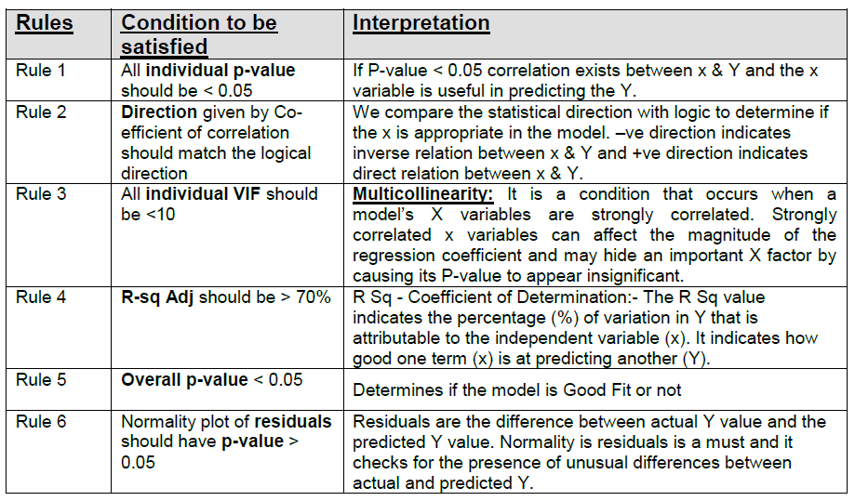

- PPM creation steps:-

    - Start considering all the data points.
    - Run the regression iterations using Minitab, check the applicable business rules (mentioned in above table) for model fitness Pass /Fail, and remove the x factor that has the lowest statistical significance to Y.
    - Perform appropriate model sanity test Pass /Fail. Remove extreme outliers (unusual observations post regression) of the residuals. Starting with observation with large standardized residual, entire row with X s and Y, needs to be removed systematically.
    - Check for match in Logical V/s. Statistical direction Pass.
    - If all above listed rules passed for regression equation, save the PPM document.

- PPM Calibration
    - PPM built at organizational level or at service line level will need periodic calibration as decided by the SEPG council (This is generally on quarterly basis). Minimum of 8 to 10 data points are required for PPM Calibration.
    - The triggers for PPM calibration are:

- Adding New Data (x’s & Y’s)
- Exclude existing x’ s

- Adding New Data(x’s and Y’s)

    - Whenever new data for sub-process measures x’s are available. For e.g.:-If PPM developed at the end of Quarter 1 and used up to Quarter 2, then by the end of Quarter 2 all the data pertaining to both the quarters are available for PPM development. The following steps are followed to calibrate PPM:

- Validation for newly added data is done by checking the data for normality, stability & capability.
- Check if the new data is statistically different from the old using hypothesis tests (2sample T test).
- If so, then build PPM iteratively i.e. Construct new PPM using only the new data and discarding the old data.
- If the data are not statistically significant then Build PPM incrementally i.e. Constructing PPM by adding new data to existing data.
- Use PPM and predict results.

- Exclude existing x’ s

- Follow the step of PPM creation as listed above, after excluding concern X.

